**Cicero Youth Bureau, Parks & Recreation**

8236 Brewerton Rd • Cicero, NY 13039-6401 • (315) 699-5233

**Kayak Rack Rental Form 2024**

KAYAK RACK

|  |  |  |
| --- | --- | --- |
| **TOP LEFT**  27” w X 20” h  $100 | TOWN USE  36” w X 40” h | **TOP RIGHT**  27” w X 20” h  $100 |
| **BOTTOM LEFT**  27” w X 20” h  $100 | **BOTTOM RIGHT**  27” w X 20” h  $100 |

Application Date________________________

Name_______________________________ (licensee)

Cell Phone___________________________ Home Phone __________________________

Email Address: ______________________________

Address: City, State, Zip: ____

Kayak Color ______________ Kayak Model _____________________

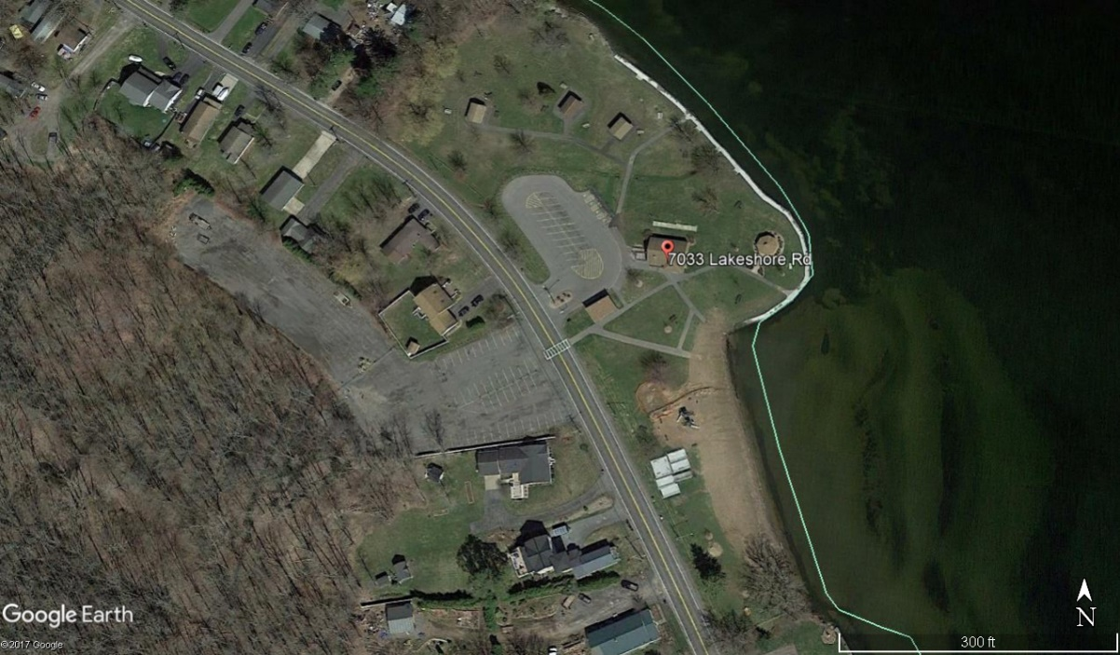

WILLIAM PARK

ONEIDA LAKE

LAKESHORE RD

A 6-unit Kayak Rack is available at the Joseph F William Park (7033 Lakeshore Road, Cicero, NY) to conveniently store your kayak for the duration of the summer boating season. The season begins on May 1st and runs through Oct 31. Rental Rates are based on this time frame.

* Rack License is available from May 1-Oct 31. Reservations for the year will be accepted starting on Jan 1 of the year. Rentals will be on a first-come, first-serve basis.
* License Rates for 2024 are $50 per season for Cicero Residents. Proof of residency is required through a verified resident account with Cicero Parks & Rec. Set up your account at cicero.recdesk.com
* Licensee is responsible for providing a lock and cable to secure Kayak to the rack.
* Payment may be made by check (payable to the “Town of Cicero), credit card, or cash. Returned checks will result in the cancellation of the permit and any boats not immediately removed by the owner shall be deemed abandoned and delivered to the Cicero Police Department for disposition as abandoned property.
* Boat Rack Storage License Agreement Form must be completed and returned with correct payment to the CYBPR by mail, email or fax, or in person
  + Mail: 8236 Brewerton Road, Cicero, NY 13039
  + Dropbox mail: 7033 Lakeshore Road, Cicero, NY 13039
  + Email: parksandrec@cicerony.gov
  + In person: William Park, 7033 Lakeshore Road, Cicero, NY 13039

**Terms of Use**

1. Cicero Youth Bureau, Parks & Recreation reserves the right to assign kayak placement on the existing rack.
2. Individuals may reserve a space for one season at a time.
3. Fee: the fee for renting a kayak rack space is **$50** for the season (May 1 through Oct 31). Payment is due prior to utilizing the rental space.
4. At the end of the rental period, the licensee will make arrangements to remove the kayak from the premises. In the event licensee fails to remove the kayak by Oct 31, the kayak shall be deemed abandoned and delivered to the Police Department for disposition as abandoned property.
5. All applicable park rules and regulations will be observed.
6. The Licensee assumes all risks related to this license and shall be solely responsible and answerable for any damages related to any accident or injuries to person or property, and hereby covenants and agrees to indemnify and keep harmless the Town of Cicero, its officers and employees from any and all claims, suits, losses, damage or injury to person or property of whatsoever kind or nature, whether direct or indirect, arising out to the operation of this License, of the carelessness, negligence or improper conduct of the Licensee or any servant, agent, or employee thereof.
7. The Town of Cicero shall not be responsible for property damage or personal injury to the licensee.
8. No refunds will be issued
9. Licensee is responsible for providing a lock and cable to fasten and secure kayak to the rack.
10. To allow access to as many people as possible, an individual may only license up to 1 storage slot

I confirm I have read, understand and agree to the terms below and I agree to the above rental and will pay in a timely manner. Rack rentals are based on a first-come, first-served basis. **I understand that by submitting this application there is no guarantee that the requested rack will be available.** Someone in the Parks & Recreation office will reach out to you within 3-5 business days**.**

Signed by *Licensee___________________________________________ Date ______________

*\*Signature must be same as name described above. This person is the official contract holder.*

Office use: Kayak Slot # Assigned for this season: _______________

Approved by: ___________________________ Date: ___________

Revised 06/3/2024